Anthony Lucchese

public class ConwaysGameOfLife {

static Boolean[][] gameLive;

final static char alive = '1';
final static char dead = '0';

static int localBestFitness = 0;
static int iterateTimes = 1;

static int totalBestFitness = 0;

public static void main(String[] args) {

gameLive = new Boolean[32][32];
insertFalse(gameLive);

//Design 1:
//only used in design 1
gameLive[16][12] = true;
gameLive[16][13] = true;
gameLive[16][14] = true;
gameLive[16][15] = true;
gameLive[16][16] = true;
gameLive[16][17] = true;
gameLive[16][18] = true;
gameLive[16][19] = true;

//Design 2:
//only used in design 2
gameLive[14][14] = true;
gameLive[15][13] = true;
gameLive[15][14] = true;
gameLive[15][15] = true;
gameLive[16][13] = true;
gameLive[16][15] = true;
gameLive[16][18] = true;

//this while loop is only used in design 1 and 2
while(iterateTimes < 1000) {
iteration(gameLive);
findBestFit(gameLive);
if (localBestFitness > totalBestFitness) {
totalBestFitness = localBestFitness;
nicePrint(gameLive);
Hexadecimal(gameLive);
System.out.println("new best fitness: " + totalBestFitness);
}
iterateTimes++;
}

//this while loop and 2 methods are only used on rand 8x8
insertFalse(gameLive);
createRandomEight(gameLive);
while(true) {
newIterations(gameLive);
iterateTimes++;

}
}
//does 1000 iterations, and prints if there is a better fitness, only used in Rand 8x8
public static void newIterations(Boolean[][] array) {
localBestFitness = 0;
createRandomEight(array);
for (int i = 0; i <= 1000; i++) {
iteration(array);
findBestFit(array);

}
if (totalBestFitness < localBestFitness) {
totalBestFitness = localBestFitness;
System.out.println("New Best Fitness: " + totalBestFitness);
System.out.println("Iteration: " + iterateTimes);
Hexadecimal(array);
}
}

public static void insertFalse(Boolean[][] array) {
for(int i = 0; i < 32; i++){
for(int j = 0; j < 32; j++){
array[i][j] = false;
}
}
}

public static void findBestFit(Boolean[][] array){
int count = 0;
for(int i = 0; i < 32; i++){
for (int j = 0; j < 32; j++) {
if (array[i][j]) {
count++;
}
}
}
if (count > localBestFitness) {
localBestFitness = count;

}
}

//uses the math.random function to generate a random boolean, only used for Rand 8x8
public static void createRandomEight(Boolean[][] array){

for(int i = 12; i <= 19; i++){
for(int j = 12; j <= 19 ; j++) {
array[i][j] = (Math.random() < 0.5);
}
}

}
//finds if the cell either keeps living, dies, stays dead, or comes alive
public static Boolean status(int x, int y, Boolean[][] array){
Boolean cell = array[x][y];
int neighbors = neighbors(x, y, array);
if (cell) {
return neighbors == 3 || neighbors == 2;
} else {
return neighbors == 3;
}
}
//returns number of neighbors
public static int neighbors(int x, int y, Boolean[][] array){
int counter = 0;
for(int i = (x - 1); i < (x + 2); i++){
for(int j = (y - 1); j < (y + 2); j++){
if(array[i][j] && !(x == i && y == j)){
counter++;
}
}
} return counter;
}
//a single iteration of conways game of life
public static void iteration(Boolean[][] array) {
Boolean[][] newGame = new Boolean[32][32];
insertFalse(newGame);
for (int i = 1; i <= 30; i++) {
for (int j = 1; j <= 30; j++) {
newGame[i][j] = status(i, j, array);
}
}
gameLive = newGame;
}
//prints only the 8x8 in user friend
public static void nicePrint(Boolean[][] array) {

for(int i = 12; i <= 19; i++){
for(int j = 12; j <= 19; j++) {
if(array[i][j]){
System.out.print(alive);
} else System.out.print(dead);
} System.out.println();
}

}
//prints only the 8x8 in hex
public static void Hexadecimal(Boolean[][] array) {
for (int i = 12 ; i <= 19 ; i++){
String hex = "";
for (int j = 12 ; j <= 19 ; j = j+4){
int k = 0;
if (array[i][j]) {k = k+8;}
if (array[i][j+1]) {k = k+4;}
if (array[i][j+2]) {k = k+2;}
if (array[i][j+3]) {k = k+1;}
hex = hex + hexConverter(k);
}
System.out.print(hex + ", ");
}
System.out.println();
}
//just a switch statement used in Hexadecimal();
@SuppressWarnings("preview")
public static String hexConverter(int i){
return switch (i) {
case (10) -> "A";
case (11) -> "B";
case (12) -> "C";
case (13) -> "D";
case (14) -> "E";
case (15) -> "F";
default -> (i + "");
};
}
//used when need to print everything
public static void printGame(Boolean[][] array){
nicePrint(array);
Hexadecimal(array);
System.out.println();
}

}

Design 1:
10000001
01100110
11111111
00011000
00000000
00011000
11111111
01100110
81, 66, FF, 18, 00, 18, FF, 66,
new best fitness: 84

Design 2:
11011111
11011100
00000010
11011110
11011101
00000000
00000000
00000000
DF, DC, 02, DE, DD, 00, 00, 00,
new best fitness: 122
Random generated 8x8
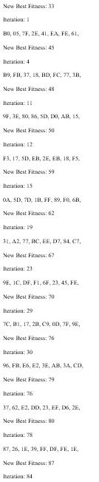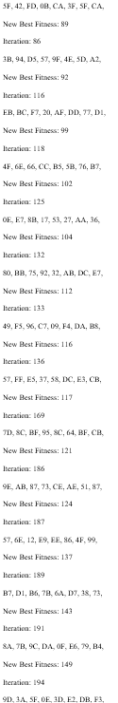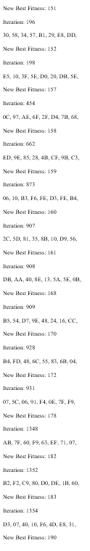
Iteration: 1398
95, EB, D3, 9A, DF, 8D, 71, 44,
New Best Fitness: 191
Iteration: 1399
37, CE, 64, E9, 09, C4, 91, 2D,
New Best Fitness: 195
Iteration: 3553
74, 2B, 3C, 47, 00, 5D, 11, D3,
New Best Fitness: 214
Iteration: 3555
72, 17, 0E, D6, A0, E6, AA, E3,
New Best Fitness: 220
Iteration: 3556
1C, 52, EC, 49, BD, 6A, FD, 99,
New Best Fitness: 230
Iteration: 3557
5A, 0C, ED, 87, 9B, 27, 0F, DF,
New Best Fitness: 237
Iteration: 17171
C9, F9, F5, 7E, 30, 2C, 5D, 79,
New Best Fitness: 250
Iteration: 70952
0010000111011001
0000100000111000
0111001101011000
1111110011100010
0010011111011111
1111011110110100
0000010010100001
1111010011001100
1D, 83, 35, CE, 7D, 7B, 4A, 4C,

